C:\Documents and Settings\Administrator\My Documents\web pictures\logo.jpg  
  
BetaCurve Interchangeable Thermistor Series I   
   
   
  
   
  
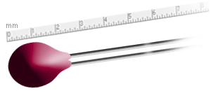

Introduction  
  
The BetaCURVE Thermistor Series I are small epoxy coated devices with Tight tolerance available - +/- 0.1 C   
  
solid tin plated lead wires. The series offers a choice of precision temperature from 0 C to 70 C tolerance classifications for a wide variety of customer applications, such as temperature sensing,control and thermal compensation.The BetaCURVE Series history of "long term" stability and reliability performance have been demonstrated in critical medical, scientific, instrumentation, military/aerospace and industrial applications.  
  
Thermistor interchangeability has become an important factor for cost efficiency in advanced thermal performance applications. The need for expensive individual thermistor calibration is not necessary. The BetaCURVE

Resistance-Temperature Characteristics for a given thermistor and will be within the specified deviation (tolerance, ie. ±0.1° C, ±0.2°C, ±0.5°C and ±1.0°C) limits over the temperature range 0°C to 70°C

Dimensions

Test.jpgTest.jpgTest.jpgTest.jpgTest.jpgTest.jpgTest.jpgTest.jpgTest.jpgTest.jpgTest.jpgTest.jpg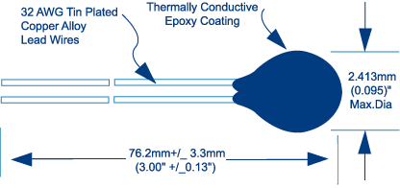

Part Numbering System

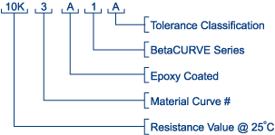

|  |  |  |  |  |
| --- | --- | --- | --- | --- |
| Pt No | Colour | Res+/-tolerance | Alpha | Beta 0/50 |
| 2.2K3A1A | Brown | 2252± 0.25%± 0.1 °C (0 to 70 °C) | -4.39 %/°C | 3892 |
| 2.2K3A1B | Brown | 2252± 0.50%± 0.2 °C (0 to 70 °C) | -4.39 %/°C | 3892 |
| 3K3A1A | Red | 3000± 0.25%± 0.1 °C (0 to 70 °C) | -4.39 %/°C | 3892 |
| 3K3A1B | Red | 3000± 0.50%± 0.2 °C (0 to 70 °C) | -4.39 %/°C | 3892 |
| 5K3A1A | Orange | 5000± 0.25%± 0.1 °C (0 to 70 °C) | -4.39 %/°C | 3892 |
| 5K3A1B | Orange | 5000± 0.50%± 0.2 °C (0 to 70 °C) | -4.39 %/°C | 3892 |
| 10K3A1A | Yellow | 10000± 0.25%± 0.1 °C (0 to 70 °C) | -4.39 %/°C | 3892 |
| 10K3A1B | Yellow | 10000± 0.50%± 0.2 °C (0 to 70 °C) | -4.39 %/°C | 3892 |
| 10K4A1A | Black | 10000± 0.25%± 0.1 °C (0 to 70 °C) | -4.04 %/°C | 3575 |
| 10K4A1B | Black | 10000± 0.50%± 0.2 °C (0 to 70 °C) | -4.04 %/°C | 3575 |
| 30K5A1A | White | 30000± 0.25%± 0.1 °C (0 to 70 °C) | -4.30 %/°C | 3811 |
| 30K5A1B | White | 30000± 0.50%± 0.2 °C (0 to 70 °C) | -4.30 %/°C | 3811 |
| 30K6A1A | Green | 30000± 0.25%± 0.1 °C (0 to 70 °C) | -4.68 %/°C | 4143 |
| 30K6A1B | Green | 30000± 0.50%± 0.2 °C (0 to 70 °C) | -4.68 %/°C | 4143 |
| 50K6A1A | Blue | 50000± 0.25%± 0.1 °C (0 to 70 °C) | -4.68 %/°C | 4143 |
| 50K6A1B | Blue | 50000± 0.50%± 0.2 °C (0 to 70 °C) | -4.68 %/°C | 4143 |
| 100K6A1A | Violet | 100000± 0.25%± 0.1 °C (0 to 70 °C) | -4.68 %/°C | 4143 |
| 100K6A1B | Violet | 100000± 0.50%± 0.2 °C (0 to 70 °C) | -4.68 %/°C | 4143 |

Resistance versus Temperature tables available

Sales: [sales@thermalcomponents.com.au](mailto:sales@thermalcomponents.com.au)

Tel: 07 55641282

Fax: 07 55296027

www.thermalcomponents.com.au